Audio Builders Workshop



Metronome kit

Build directions

### Introduction

This kit is intended as a beginner level kit to introduce you to assembling your own electronic projects. If you received this kit at an AES/ABW event then most likely there are volunteers on hand to answer questions while you follow this guide to assemble the kit. If you’re running a learn to solder event and need guidance on organizing and running the event please see the document “*HOSTING A LEARN TO SOLDER BUILD EVENT*” or contact ABW.

If you received this kit for assembly at home many general electronic assembly questions can be answered from resources found on the internet.

If you get stuck and need help please post your question on the Audio Builders Workshop’s Facebook page <https://www.facebook.com/groups/AudioBuildersWorkshop/>

These build directions were update 30-Jun-2018 to provide information for the rev 2.0 PCB. There is no meaningful difference in the build directions if you happen to have a Rev 1.0 or Rev 2.0 PCB. The pictures in this document are from the Rev 1.0 PCB. A further revision of this manual was done 1-May-2019 to clarify the wiring of the ¼” jack and speaker.

As of version 6 this guide was updated to reflect the change of a few components. This substitution of components happens for various reasons and depending on when you got your kit not all of the parts may look exactly like the ones shown here, though they will always be functionally equivalent.

### Where to get kits

All source files, including BOM, are available. If looking for one or a small number of kits, ABW has set up Crowd Supply to sell kits for both this Metronome kit and the Low Pass Filter kit. See <https://www.crowdsupply.com/> for details.

### About the audio builders workshop (ABW)

The ABW is a working group of the Boston Chapter of Audio Engineering Society. The ABW promotes interest in electronics construction and design for applications with audio. In addition to kit building the ABW sponsors all day seminars on various technical topics related to audio and recording of audio. The Boston AES also runs shorter (1 to 2 hours) lectures, company visits, and networking events once or twice a month. All ABW and Boston AES events are free to attend, though there are materials fees for purchasing kits.

Many of the events are posted on the ABW You Tube channel, including a substantial back catalog of talks: https://www.youtube.com/audiobuildersworkshop

### About this kit

The kit contains all of the parts needed to create an electronic metronome based on an Integrated Circuit (IC) known as the 555 (usually said as five fifty-five). First sold in the 70’s, it has been used in thousands and thousands of products. There are currently dozens of different versions manufactured by multiple companies. In a simple application like this almost any 555 part will work.

This kit includes some features not seen in some of the very cheap kits available on-line:

* Line out: connect to your amp or other equipment via the ¼ phone jack.
* LED for visible indication
* Two operating modes: flash + line out, or flash + lineout + speaker.
* Input diode to protect against connecting the battery backwards
* Use of a low power version of the 555 IC part to extend battery life
* Power supply and CV pin decoupling to ensure reliable operation
* TEMPO adjustable from about 30 bpm to *ludicrous* speed

We assume a first time builder; these directions provide a lot of detail in the assembly steps that an experienced builder will probably be annoyed with.

As a first time builder you may not know much about soldering; we refer you to other resources to provide more information about soldering technique as there’s no value to repeat that here (cause the author’s fingers are already tired from typing this up…)

### More info

Where to get this document or the source files to the design: <http://clk.works/2018/05/audio-builders-workshop-metronome-project-source-files/>

Licensed under 

### WARNING

This electronics kit requires use of hand tools including a hot soldering iron capable of severe burns, and chemicals that may be dangerous if used improperly. You must use common sense safety precautions when assembling this kit. You agree to hold ABW and anyone else that can fog a mirror harmless should you injure yourself. If you are not willing to accept these risks please do not attempt to assemble this kit.

We suggest using tin/lead solder as it is easy to use and the results are better than the alternatives. But if you eat the stuff your brain will be permanently trashed, and maybe other critical body parts go south too. So yeah, don’t eat it and don’t leave it around where someone else might think it’s shiny string cheese.

# Getting ready

Set up a workspace where the tools that you will need will be easily accessible and you can work safely with a soldering iron.

Tools needed:

|  |  |
| --- | --- |
| * Soldering iron * Solder tip cleaner (wet sponge) * Solder (no clean flux suggested) * Board holder/3rd hand tool * Wire strippers * Tray to keep parts in * Needle nose pliers | * Wire cutters * (optional) component lead bender * (optional) magnifying lens/lamp * (optional) voltmeter for testing * (optional) glue gun/hot melt * (suggested) Grounded ESD wrist strap |

If you have not soldered before we suggest viewing related videos (see for example <http://www.instructables.com/id/Beginners-Guide-to-Soldering/> ) as well as reading this guide:

<https://mightyohm.com/files/soldercomic/FullSolderComic_EN.pdf>

Please read through this manual before starting assembly so you understand how the steps proceed before you start. We know you won’t, but don’t say we didn’t warn you!

## Precautions

The integrated circuit (IC) used in this project can be damaged by static electricity. You should assemble this at a static free workstation. If you don’t have that you should touch a metal object before picking up any components. If you feel a static discharge then your work area is definitely not static safe and you should at least get an ESD grounding wrist strap. Even if you don’t feel a static discharge your body may accumulate a charge that can damage the IC used in this project; touching the metal first reduces the chance of damage but is not a substitute for proper static control.

Avoid breathing fumes when soldering. Your work area should include a fan to draw the fumes away.

Solder is hot when liquid and will cause burns if it contacts your skin. Avoid creating large blobs that can splatter.

The solder used contains lead. Wash your hands after handling it.

# Parts identification

Abbreviations used:

uF = micro farad (one millionth)

K = 1000

Ω = ohm

Pot = Potentiometer, Variable Resistor

PCB = Printed Circuit Board

W = Watt

The color of the capacitors in your kit (the first three parts below) may differ from what is shown in these pictures. The capacitance value is what is important to identify the correct device. The other markings may be different. The resistor color codes are detailed later.

|  |  |  |  |
| --- | --- | --- | --- |
| Capacitor 22 uF    (x3) | Capacitor 2.2 uF | Capacitor (x2) 0.1 uF    (x2) | IC TLC555 |
| Diode (1 amp) 1N4004 | Diode small 1N4148 | LED – Green | 9V battery clip |
| Resistor 10 ohm 1W | Resistor 330 ohm ¼ W    orange-orange-brown | Resistor 1K ohm ¼ W    brown-black-red  (x3) | Resistor 10K ohm ¼ W    brown-black-orange |
| Switch DP3T | Pot, 100 K ohm, 9mm size | Speaker, 1/2W, 16 ohm | PCB |
| Hookup wire | Output connector ¼” phone  Amphenol | Alternate output connector (you will have only one of these two types) | 9V battery included at events, not included if mailed. |

A case is not supplied but is a good idea to protect the system from damage.

## Notes

Use caution when bending component leads to not damage the component.

The variable resistor (used to set the TEMPO) has two mounting tabs that must be slightly spread for the part to mount correctly on the Rev 1.0 PCB. This was corrected with the Rev 2.0 PCB.

### Polarized components

There are several components that must be installed in a particular orientation to avoid failure.

(Electrolytic) capacitors. These are marked with a “-“ (minus or negative) stripe on one side, meaning that the side opposite the “-“ is the “+” (plus or positive) side. For historical reasons the PCB labels the “+” connection.

Diodes. There are two different diodes used. Both have a band marking the cathode (“-“) end and should be installed as indicated on the PCB.

LED. The cathode end is marked by either a flat side or a small notch.

IC. One end of the chip may have a notch in it, or there will be a round dimple/marking to indicate pin 1. On the PCB the notch and dimple are both marked. (different vendors mark their parts differently)

### Identifying resistors by their color code

Hold the part so the 3 grouped colored bands are on the left and note the colors. The fourth band on the right side isn’t important in this application. In this circuit design the 10 ohm resistor is physically bigger because it can dissipate up to 1 Watt of power versus ¼ Watt for the other resistors.

You can learn the details of reading color codes on line, for example <https://www.digikey.com/en/articles/techzone/2017/apr/big-boys-race-young-girls-violet-wins-resistors-color-codes>

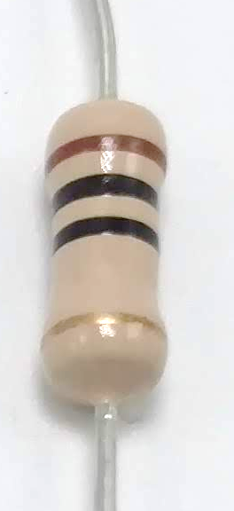

10 Ω: Brown Black Black

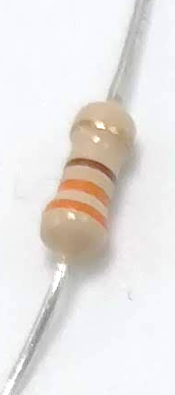

330 Ω: Orange Orange Brown

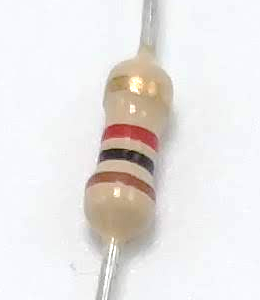

1KΩ (1000): Brown Black Red

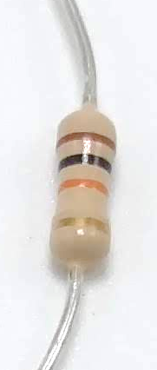

10KΩ (10,000): Brown Black Orange

## Part identification versus reference designator

When we refer to the *value* of the part it’s typically something like its resistance (described in units called ohms) or its capacitance (in units called farads, though in this design microfarad part values). Other parts are identified by a type number (for example 1N4004 for a diode).

The values/identifiers identify the part, but not where to install it on the PCB. For installation location values referred to as *reference designators* are used. Typically the reference designator (ref-des for short) is a letter followed by a number. The letter identifies the type of part (R = Resistor, C = Capacitor, etc) and the number is just a sequential ID.

The relationship between the ref-des and the part value is specific to a particular PCB design. A table is needed to map between the two. In this design we have placed the value on the PCB silkscreen (the white lettering) to make this process easier.

# Soldering

This section only provides a summary; if new to soldering please see the guides described earlier.

The metronome project is a single sided PCB and therefor easy to solder. Assuming Sn/Pb (you remember high school chemistry, right?) solder and a conventional iron, set the tip temperature to 340C (650F). Make sure the tip is clean and well tinned. Hold the iron so that it is heating the pad and the component lead equally.

Apply solder to the joint – not to the tip of the iron. Remove the iron as soon as the solder has flowed and made a good connection. Holding the iron on the joint for too long will damage the components.

The solder should form a nice smooth fillet around the lead. If the joint has a dull grey look to it the solder was disturbed as it cooled, creating a cold solder joint that will not function as expected. Reheat the joint to correct.

After the component is soldered trim the leads, being careful to hold the wire end so it doesn’t shoot off and poke your or someone else’s eye out. (obligatory reference to the 1983 movie *A Christmas Story:* ***you’ll poke your eye out kid…***)

Assuming no-clean solder flux is used there is no need to clean the board after soldering. If solder with conventional flux is used then the board must be cleaned with the appropriate flux solvent after assembly is complete.

## Rev 2.0 board note

For those that want to know all the details (i.e. you can skip to the next section): It was observed that with the Rev 1.0 PCB people new to soldering sometimes ended up lifting the pads off of the board, which is the downside to making this a single layer board (the upside: really easy to fix mistakes). This can happen for a number of reasons but is usually related to finding the right balance between the soldering iron temperature and the length of time the soldering iron is applied to the joint.

Since this board is intended for people totally new to this we wanted to make this less of an issue; the pad sizes were increased on the Rev 2.0 PCB which should make this problem less likely to occur.

If you’re assembling this at home and do lift a pad, don’t fret. You can solder a wire between the part and whatever else it connects to. If you’re unsure about what to do please post on the ABW Facebook page for help.

# Bending lead for resistors and diodes

You will need to carefully bend the leads for the axial leaded components, which are resistors and diodes in this design.

In the rev 1.0 board the axial component leads (except for the 10 ohm resistor) are spaced 0.4” apart. Use the needle nose pliers to hold the component by the lead about 0.1” from the body of the part, and bend the lead down.

Rev 2.0 boards the spacing for resistors was increased to .6” for people that have a “junk drawer” of parts to use a wider range of parts.

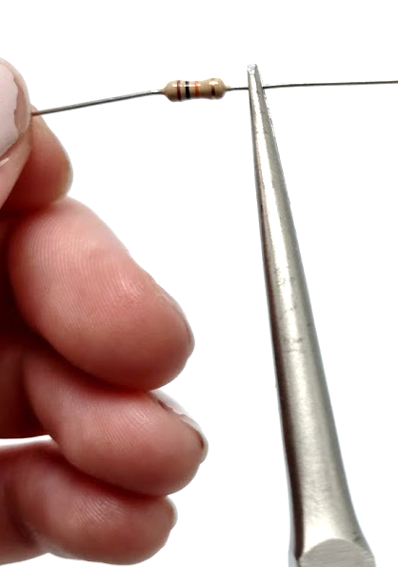

Figure 1 Bending the leads with needle nose pliers

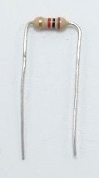

Figure 2 After bending both sides

Once the leads are formed the component can be inserted in to the board to check that you have the spacing correct, as shown in the next sequence.

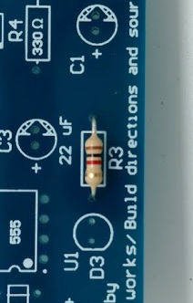

Figure 3 Inserted in to the board

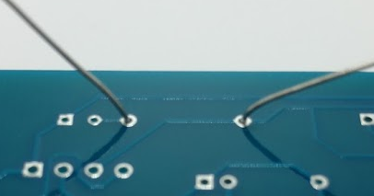

Figure 4 Leads bent on backside to hold component

For remainder of the manual the steps to bend the leads will not be explicitly called out.

# Overview of assembly steps

For this board it is easiest to start with mounting the shortest components, soldering them, trimming the leads, and then moving on to the next higher type of component. This works because if you flip the board over to solder it most of the parts will lay flush.

The use of a “3rd hand” tool can make the process much easier as you can angle the board more conveniently and bending the leads on the back will hold must components in the board correctly.

Note that since components are soldered and leads trimmed as you go you will need to recheck that you have all components correct as you go. If you do make a mistake the single sided PCB makes it relatively easy to remove components; the details of that are beyond the scope of this guide.

The board documentation includes a 3D PDF that you can rotate and zoom in on (requires PC/Mac version of Adobe Reader). This can help you better understand how the board goes together.

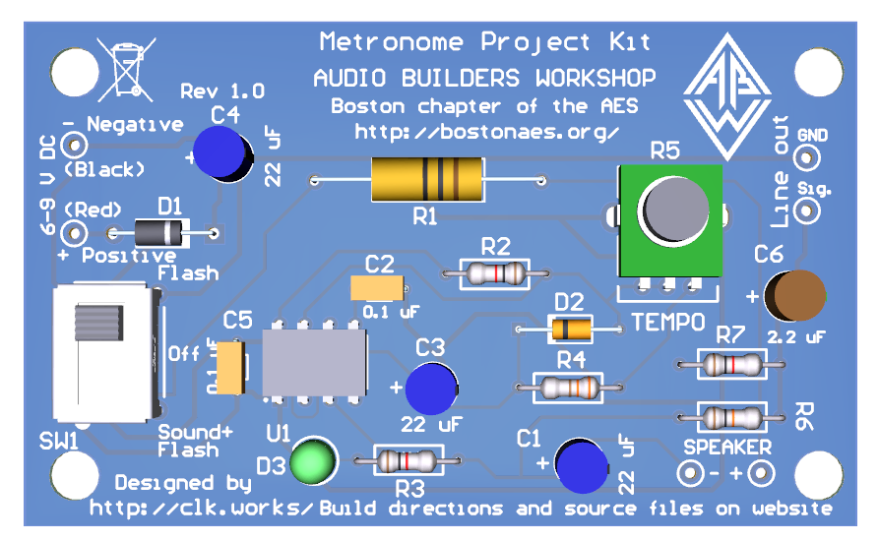

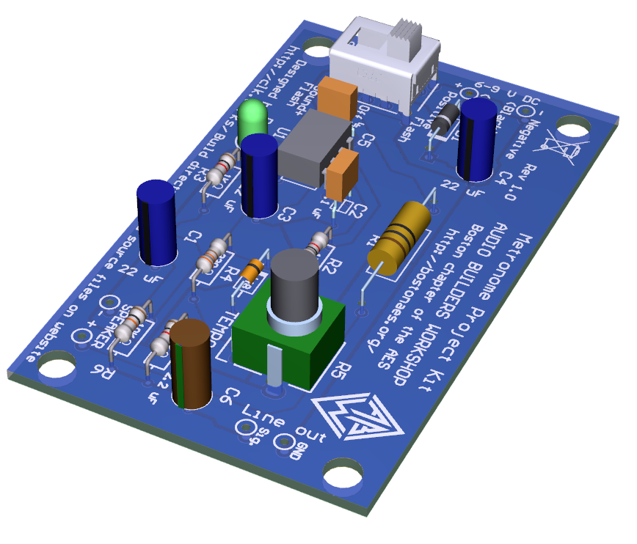

Figure 5 From the 3D views of the board

## suggested assembly order

We propose you assemble this board from shortest to tallest component height.

* ¼ W resistors
* diodes
* 1W resistor
* 555 IC
* Ceramic caps
* LED
* Electrolytic caps
* Switch
* Pot
* Wires (battery clip, speaker, output jack)

## Things to think about before you start

The speaker will be considerably louder if it is mounted in a case of some sort with sealed back and a grill or opening for the front of the speaker. If you intend to mount the board in the same case consider where the battery will go and be attached to the case, as well as the output jack.

If the board is mounted in the case then you may wish to use a panel mount switch, pot, and LED. While you can unsolder components later to change the mounting it’s much less work to assemble the board how you want it to end up.

The rest of these build directions assume all parts mounted to the board, and the board on the outside of the case, with the battery, speaker and output jack mounted inside a case.

# Step 1 : 1/4W resistors



**330Ω**

**10KΩ**

**1KΩ**

**1KΩ**

**1KΩ**

Figure 6 Locations of the 5 resistors to install

The values for each location are marked on the PCB and listed here as well:

R2: 1KΩ (Brown Black Red)

R3: 1KΩ (Brown Black Red)

R4: 330Ω (Orange Orange Brown)

R6: 10KΩ (Brown Black Orange) (do not confuse with the 10Ω part)

R7: 1KΩ (Brown Black Red)

Insert those five components. Bend the leads to hold them in place, and then recheck that the parts are installed in the correct location. The resistors can be installed in either orientation, they are not polarized.

Once you have rechecked that you have all 5 in the correct locations solder them. You should clean and tin the tip before starting to solder, and reclean/tin it as you go along.

When all parts are soldered carefully clip the excess wire leads. Be sure to hold on to the lead as they can be ejected during the cutting process at high velocity and travel several feet – becoming a hazard to you and those around you in the process.

# Step 2: Diodes

There are two different diodes to install.

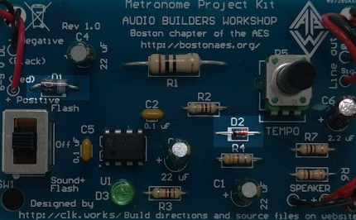

Figure 7 Location of the two diodes

The 1N4004 part has a black body and is installed in the D1 location. This part MUST be installed with the cathode end (the white band) to the right as pictured above and as marked in the silkscreen. The board will not work if this part is installed backwards.

The other diode, D2, is a 1N4148 type and has a glass body with an orange color. Like all diodes, it must be installed correctly for the circuit to work. There is a black band on it, and the band must be to the left as shown in the picture and marked in the silkscreen.

Verify the orientation of the two diodes and then solder and trim the leads. The diodes are more sensitive to excess heat (along with the LED and IC); please use caution soldering this part.

# Step 3: 1W resistor

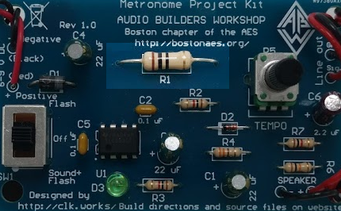

Figure 8 10 ohm R1

As there’s only one 10 ohm 1W part it should be very straightforward to do this step.

As with the other parts, insert the 10 ohm 1W resistor into the ref-des R1 position, solder it, and then trim the leads.

# Step 4: 555 IC

This component can be damaged by static electricity.

Pin 1 is indicated by a round circle and/or a divot on one end of the package. If there’s a divot on one end then with that on the left side pin 1 is the lower left pin. On the PCB the ref-des for the IC is U1.

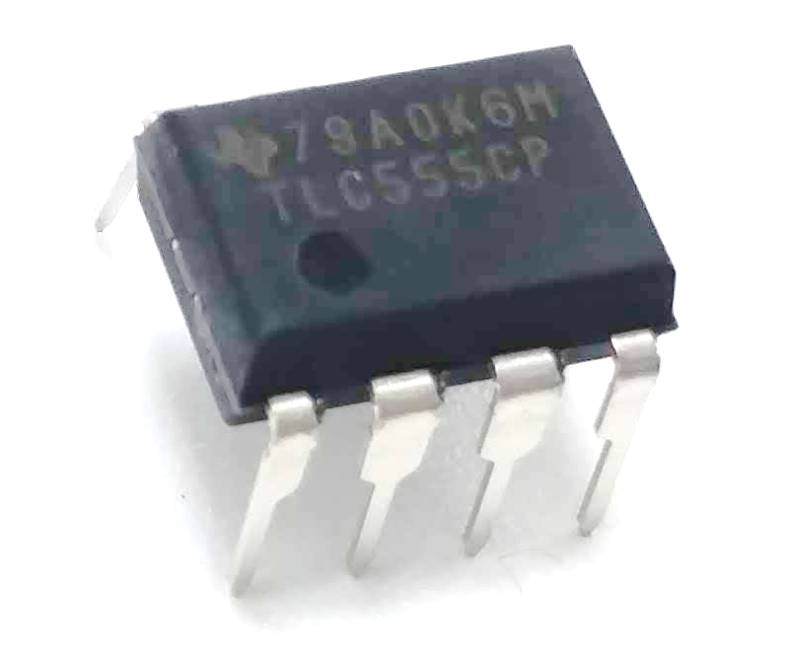

Pin 1 indicator

It is critical to install the IC correctly as installing it backwards may release all of the special magical smoke inside of the parts.

The PCB silk screen indicates where pin 1 goes with a dot. Assuming you hold the board in the same way as shown in the picture, pin 1 is the left lower corner.

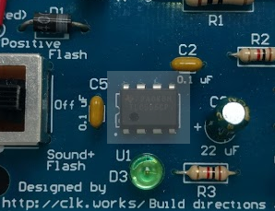

**Notch and/or dot**

**Pin 1**

When installing the IC you will need to squeeze the leads slightly to get the pins and holes to line up. You can do this by putting in one side and then pushing against the body of the part to get the other side lined up.

It won’t be possible to bend the leads to hold the part in the board, you will need to hold the part while getting the first bit of solder on one of the pins to hold it in place. A 3rd hand tool is very helpful for this step.

While all of the parts are sensitive to the heat from the soldering process the IC is particularly sensitive, so you should use the minimal amount of heating time to make a good connection.

It is not necessary to trim the leads after soldering.

# Step 5: Ceramic caps

There are two of these parts to install, C2 and C5, both with the same value. They may have kinked leads that hold the body of the part above the PCB by a tenth of an inch. Do not try and force them in further.



Figure 9 C2, C5 (0.1uF ceramic)

Install them at the locations labeled C2 and C5, solder and trim the leads.

# Step 6: LED

There is only one LED to install; in most kits it will be a green LED. The LED must be installed in a particular orientation to work. One side of the LED will have a small notch or flattened side to it. That side must be matched to the flat on the silkscreen marking for D3.

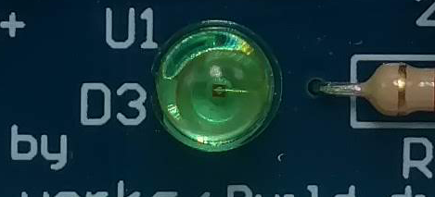

**Flat or notch**

Figure 10 LED orientation

You may also notice (you might need a magnifying glass) a very small wire inside the part, it should be on the right side, as shown in the above picture.

Another way to determine the orientation is from the lengths of the wire leads, as shown in the next illustration. The shorter lead corresponds to the same side as the notch. (the technical term for this lead on a Light Emitting Diode is called the *cathode*).

Figure Identifying the cathode side by lead length

**Shorterlead**

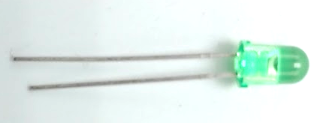

**Flat or notch**

After double checking the LED’s orientation solder it in place. The part can be more easily damaged by excess heat than most of the other parts (the IC and diodes being the other sensitive parts).

# Steo 7: Electrolytic caps

There are two different values to install, three 22 uF (C1, C3, C4), and one 2.2uF (C6).

The capacitors must be installed in their correct orientation or the system will not work.

NOTE: In some kits the 2.2 uF (C6) capacitor may actually be a special type that is NOT polarized, and therefor it will NOT have a stripe on one side, and it can be inserted in either orientation.

All of them are oriented the same way and the silkscreen pattern has a “+” on one side and a hatch pattern on the opposite side for the “-“ (negative) side, which is indicated by a stripe on the capacitor.

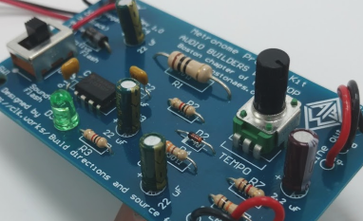

Figure 12 Showing negative side marking on C1, C3, C4, and C6

Note that the capacitors in your kit may have a different color than that shown in the photo.

Install the 2.2 uF capacitor at C6 (right side of board). The negative side (stripe) is on the right. Then install the three 22 uF capacitors at C1, C3, and C4.

After verifying the polarity and that the 2.2 uF capacitor is installed at C6, solder the parts and trim the leads.

Note: In some parts kits the capacitors may have bent leads that are spaced wider than the holes in the PCB. If your parts kit includes parts like that carefully straighten the leads with your needle nose pliers.

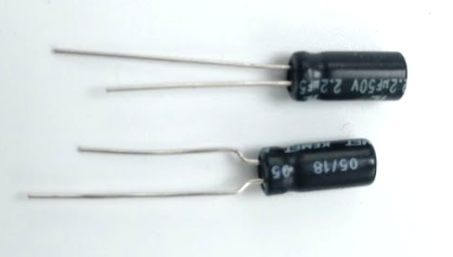

Figure Example of straight lead (top) and bent lead (bottom) that need to be straightened to fit.

# Step 8: Switch

Install the switch on the left side of the board. It does not need to be oriented any particular way. If you bend out one of the four outer legs a little that will help hold it in the board while you solder. It is not necessary to trim its leads.

The large mass of metal on the four outer corner pins may make soldering those difficult. As they are only for mechanical support it is not critical to fully solder them.

# Step 9: Pot

On Rev 1.0 boards the two upper tabs need to be bent slightly before inserting the part in the board.

Make sure the part is pushed all of the way in and laying parallel to the board before soldering. It is not necessary to fully solder the two large tabs, soldering one side of the them is sufficient. The large mass of metal attached makes soldering them more difficult than regular components. It is not necessary to trim its leads.

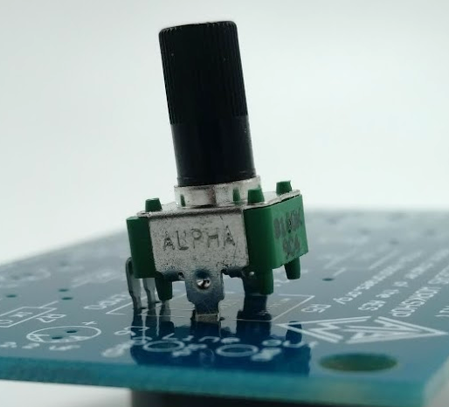 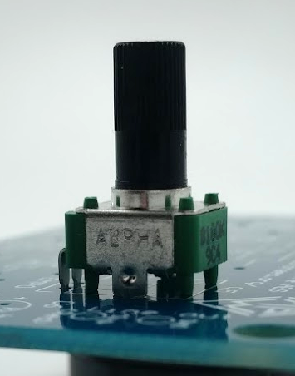

**Incorrect pot installation. Correct pot installation.**

Figure Ensure the pot is flush with the board.

# Step 10: Wires (battery clip, speaker, output jack)

Before attaching wires to the board they should be attached to the speaker and output jack. The supplied 9V battery clip already has wires attached.

For the speaker and output jack the kit includes 16” of red and black wire to cut to make a pair of 8” (22cm) leads for each. Some kits may have them precut. If not cut them to the desired length and strip about 1/8” (3 mm) of insulation from each end, being careful to not nick the wires. Use red (positive) and black (negative) in pairs.

To keep the setup neater so they don’t get tangled it is suggested to twist the wires a few times.

Once all of the wires are attached it should look like this:

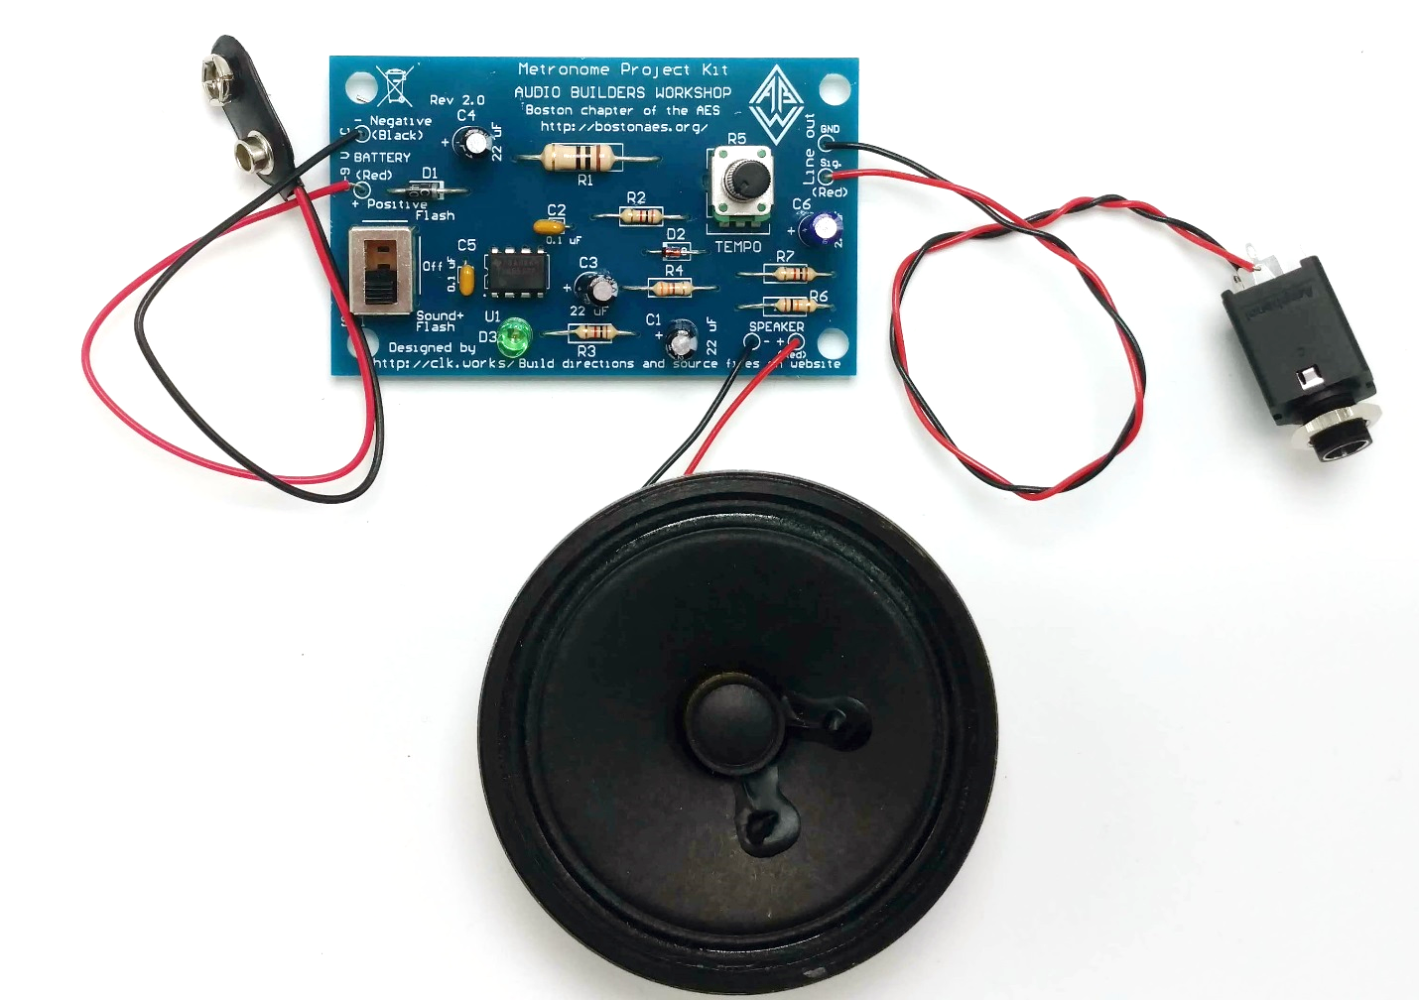

## Step 10A: Wires to the speaker

Some speaker may have lugs with holes in them that the wire can be inserted through and wrapped around. Others may have lugs with no holes (right side picture below)

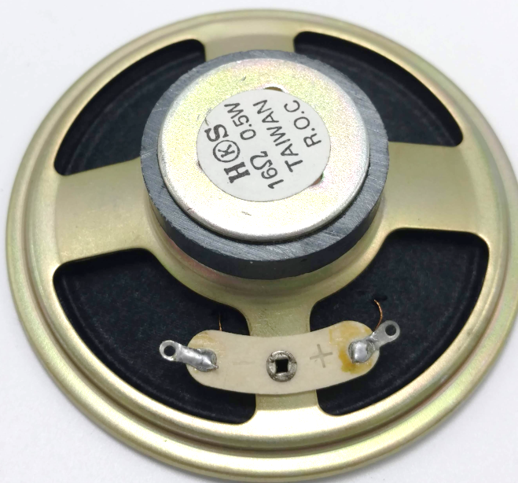 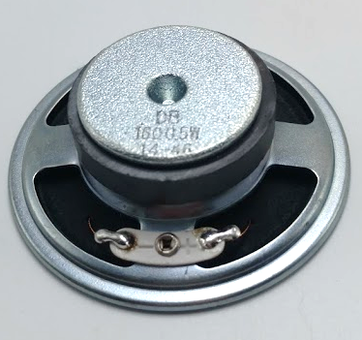

Figure 15 Back of speaker

Insert the red wire in to the + terminal (lug) hole. Using the needle nose pliers bend the wire over to make a small loop around the hole. Orient the wire in the same direction that it will come off of the speaker in your case (if mounting). Then carefully solder the joint, being careful not to touch the soldering iron to other parts of the speaker.

If your speaker doesn’t have holes in the lugs then carefully strip a total of about 1/4” (6mm) of insulation off one end of a pair of black and red wires. Wrap that around the narrow part of the lugs (red to + marking) and solder.

Repeat this for the black wire in to the other terminal.

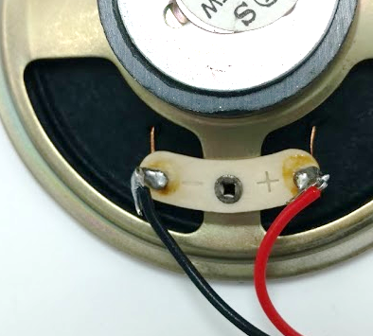 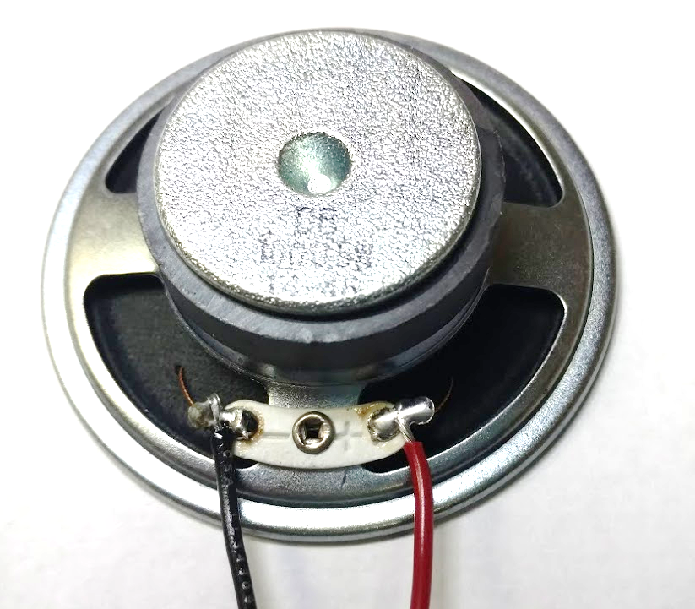

Figure 16 Speaker after connecting the wires

Set the speaker aside as we’ll prepare the output jack next.

## Step 10B: Wires to the output jack

To avoid shorting the output when a mono (single channel) plug is used only the tip is wired. Take another pair of red and black wires (not ones attached to anything!) and attach them to the jack as shown below. The jack may be different in your kit; please modify these instructions if needed to match the hardware you have. Two different jacks are illustrated in this section.

Black wire is traditionally used to indicate the *ground* side of the connection.

#### Plastic cased jack

You can wrap the wire around the pin. Some of the jacks require considerable heat to form a good solder joint, you can aid that process by ensuring your tip is clean and flowing some solder on to the tip to maximize the contact area.

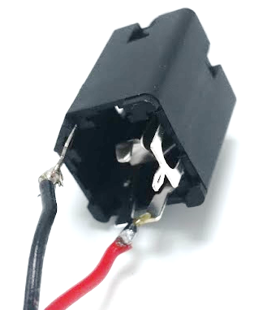

Figure 17 1/4" jack wiring (black on left, red on right)

The jack shown in the picture has its terminals in STR (Sleeve Tip Ring) order. Solder a black wire on to the shell/shield pin. On the jack pictured this is the pin with the angled corner in the plastic. The holes for the wires are a little narrow, you may need to spread the wire a bit to fit it through.

The middle terminal pin is the tip, insert and then solder the red wire to that. The jack includes a nut so that it can be panel mounted.

Here’s a different view of the wired jack:

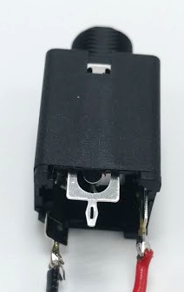

Figure 18 1/4" assembled jack (black on left, red on right)

#### Exposed jack

If your kit includes this jack here’s how to wire it. Place the jack with the lugs facing you and the entry facing away, as shown in the next picture.

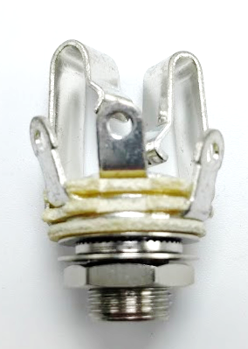

Figure Jack. From left to right the three solder lugs are: Tip Sleeve Ring

Wrap the stripped end of the red wire around the left (tip) lug and the black wire around the center (sleeve) lug, and solder.

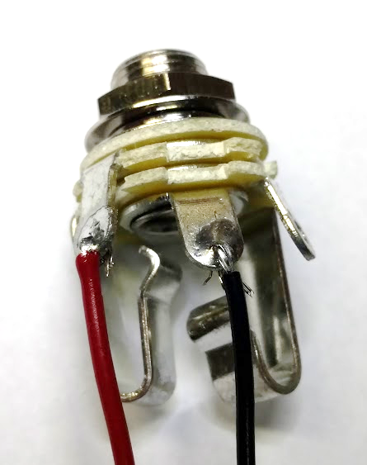

Figure Wired jack. Red (tip) on left, black (sleeve) on center.

# Step 11 :Wire to the board

At this point you should have the speaker with the wires attached and the jack with the wires attached.

If the board is going to be mounted in a box then the leads can just be attached without strain relief. If the kit will be used loose on a table then some sort of strain relief is needed for the wires as they will break off from the repeated bending.

One option is to loop the wires through the mounting holes, as illustrated below:

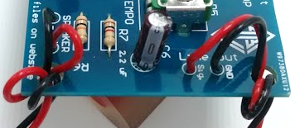

Figure 21 Looping wires through mounting holes for strain relief

Another option is to place some hot melt on the top of the wires at the connection point to take the strain off the solder connection. The battery wires are smaller than the other wires and therefor the most likely to break.

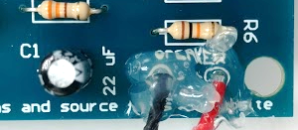

Figure 22 Using hot melt instead of looping wires through the holes

## Step 11A: Battery wires

Start by inserting the battery wires into the two holes on the left side of the board labeled 6-9 V DC. (looping them though the mounting hole if needed for strain relief). Black (negative) and Red (positive) must be wired to the correct holes as indicated in the silkscreen.

As with the other components bend the wires over on the back to hold them in place and then solder them. Trim the excess wire after soldering.

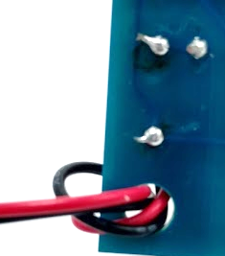

Figure 23 Back of board where speaker wires attach

## Step 11B: Speaker wires

Follow the same procedure for connecting the speaker wires. + is red, - is black.

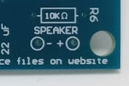

Figure 24 Speaker output connection location

## Step 11C: Output jack wires

As with the other two wired connections, connect the output jack wires to the PCB in the marked holes. The output jack signal (tip) is red, and the sleeve is GND is (black wire).

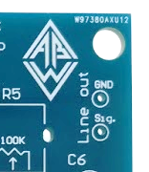

Figure 25 Line out connection location

If using hot melt for strain relief instead of looping the wires you can do it now or after you test the board.

# Step 12: Before you connect the battery

At this point all components should be installed. If not figure out what you missed and correct.

Carefully inspect the back of the board for solder shorts between pins, cold solder joints, or partially soldered joints. An illuminated magnifying glass makes this step much easier. Correct any problems found.

Recheck all of the polarized components for correct part orientation:

* C1, C3, C4, C6
* D1, D2, D3 (LED)
* IC installed with pin 1 in correct location

# Testing

Put the switch in the middle (off) position.

Connect the battery and put the power switch in the “up” position (Flash).

The LED (D3) should start to flash – turn the TEMPO knob to see it slow down or speed up.

Now place the switch in the down position and you should hear a click synchronized with the LED flash.

You can also check that the line out is operational – it is active in both switch positions.

If everything works then you are done! Congratulations on building the metronome kit.

# In (a) case

This picture shows one possible way to mount the board and speaker in a case along with the battery, It’s shown here with a cheap plastic hinged case from a local art supply store. The pot, LED, and power switch were soldered to the back of the board to achieve this, which is a more complex undertaking than the procedures described so far.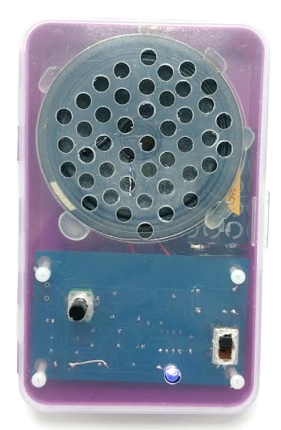

# Trouble shooting

If the LED fails to light with the switch in the up position and the TEMPO knob in its full clockwise (fastest) position, then return the switch to the off position and disconnect the battery.

Reinspect the board for shorts, bad solder joints, or places where a soldered connection was missed.

Apply gentle pressure on each component; it should not shift position. If it does then it has a bad solder connection.

Bad solder connections can usually be fixed by just reheating the joint, sometimes a small amount of additional solder may be needed.

If you do not see any bad solder connections then verify the following:

* D1 is installed correctly (band on the right side)
* U1 installed correctly (pin 1 in lower left)
* D2 installed correctly (band on the left side)
* D3 (LED) installed correctly (notch or flat side on left)
* Polarized capacitors C1, C3, C4, C6 installed correctly (stripe/- on right side)
* Correct values at all locations of resistors and capacitors

If no problems are found then a meter will be needed to measure voltages.

First verify the battery voltage is 9V (or somewhat discharged battery night read 7 or 8V but will still work).

Turn the switch to the flash position.

Measure the voltage between the battery “-“ terminal (which is also connected to the metal case of the switch and the pot) and the D1’s cathode (right side). With a battery voltage of 9V you should measure about 8.3 V. (anything between 6 and 9 would be fine here).

Measure the voltage on U1 between pin 1 and pin 8. Pin 1 is the lead with the circle next to it, pin 8 is the pin directly across from it. Be careful to not short these pins to other pins when measuring. You should measure the same voltage as at D1, about 8.3V with a fresh 9V battery.

If you don’t measure the correct voltage then recheck the switch and IC soldering.

While a component failure is possible (but very unlikely) most faults are created during assembly – bad solder joints, wrong orientation of polarized components, or wrong component installed.

# The good stuff

This document and all of the source files associated with this project are Copyright 2019 by the Audio Builders Workshop (ABW).

<https://www.facebook.com/groups/AudioBuildersWorkshop/>

a working group of the Boston section of the AES

<http://bostonaes.org/>

All materials are licensed by the ABW under the Creative Commons Attribution-Share-Alike license CC-BY-SA: <https://creativecommons.org/licenses/by-sa/4.0/legalcode>



Recognition is given to <https://microphone-parts.com/> for the general structure of this build guide; we really like the way their manuals are written and apologize in advance at this feeble attempt to emulate their materials.

Huge thanks goes to Crowd Supply for making this kit available!

The ABW build events at the AES New York City conventions have been sponsored by Mouser, so a hige thank you to them too.

Design and documentation developed by Clockworks Signal Processing LLC for ABW.



<http://clk.works/>

**GO FORTH AND BUILD!**